Sampling Distributions and
Confidence Intervals for a Mean
Problem Set
The goal of this activity is to explore sampling distributions for mean and use properties of the sampling distribution to create confidence intervals for a mean.

In this activity, you will be exploring the concepts of the sampling distribution and the confidence intervals for a mean.
SAMPLING DISTRIBUTION FOR A MEAN
Although you will see that you have the population in this section, you are going to pretend that you do not. Instead, you are going to focus on investigating how estimates/statistics from random samples vary. (Note: This section of the activity will look similar to a previous problem set, but now you will be exploring a different statistic, the sample mean.)
- Go to http://lock5stat.com/statkey/.

- Click on link for Sampling Distributions > Mean.

- In the upper left corner, you will see a button that says Baseball Players-3e (2019 Salary in millions). Click on that button and scroll down to Percent with Internet Access – 3e (Countries). This is the context you will be using in this activity.

Examine the Population box in the upper right.

- Describe the shape, center, and variability of the population distribution for the percent within a country with internet access. Be sure to describe the center and variability in the context of the problem.

The shape of the population distribution is asymmetrical. It’s center is at 54.47. And it’s standard deviation varies by 28.38

- Click the button that shows 10, next to the words Choose samples of size n= in the middle of the top row.

- Enter the value of 50 and hit the Ok button (or hit Enter).

- Click the Generate 1 Sample button on the left side of the second row to take a random sample of 50 Countries.

Examine the sample box in the lower right to see the distribution of the sample (the sample distribution.)

- Describe the shape, center, and variability of the sample distribution for the 50 randomly selected countries. Be sure to describe the center and variability in the context of the problem.

The shape of the sample distribution is asymmetrical. It’s center is 55.48, and it’s standard deviation is 26.57.

Examine the Sampling Dotplot of Means, which is the primary plot on the left.

- There is one point on this graph. Please share its value (up to 3 in the collaborative key) and explain what this value represents.

55.476 represents the mean value of the sample.

- Click the Generate 1 Sample button on the left side of the second row to take a second random sample of 50 Countries.

- Describe the shape, center, and variability of the new sample distribution in the lower right graph. Be sure to describe the center and variability in the context of the problem.

The shape, center, and variability of the new sample is the following, respectively: asymmetrical, 52.33, 31.95. In this context, the shape means that in countries with internet access are not uniformly distributed.

- Note that there is now a second point on the main graph, called the Sampling Dotplot of Mean. Compare the second point to the first point. Are they the same? Why do you think that is?

No, my second value is different from my initial value. They are different because the likelihood of obtaining the same sample values (n=50) is extremely low, and thus, this discrepancy in means occurs.

- What do you suspect the second point’s value is? How do you know?

The second point’s value is 55.476 because it is right below 52.5. I know because I can see it on the Sampling Dotplot of Mean graph.

- On the Sampling Dotplot of Mean, there is an arrow with a number below it. Calculate the average of the values identified in question 3 and question 5 and compare to the number below the arrow. Show your work.

The average of values between the two mean is 53.901.

- Now generate at 10 samples by pressing the Generate 10 Samples button.

- Examine the Sampling Dotplot of the Mean graph. Describe the shape, center, and variability of the 12 points.

The shape, center, and variability of the twelve points is asymmetrical, centered at 57.464, and variability is 27.715.

- Now generate at least 10,000 samples by pressing the Generate 1000 Samples button.

- Share a screenshot of the sampling dotplot below. (Share up to 2 plots in the collaborative key.)

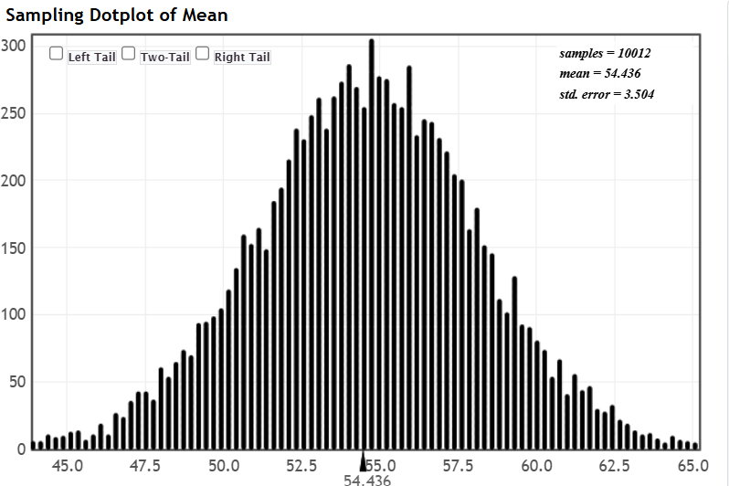

- What does each dot in the sampling dotplot represent?

Each dot in the sampling dotplot represents each individual sample mean value.

This sampling dotplot is a simulation of the sampling distribution for a (sample) mean.

- What is the approximate shape of the simulated sampling distribution for a sample mean?

The shape of the sampling distribution is a bell-shaped curve.

- Where is the simulated sampling distribution centered? Why does this make sense?

It is centered at 54.436. This makes sense because the sampling distribution mean is closer to the population mean because we significantly increased the sample size. Therefore, increasing the sample size results in a more accurate sampling distribution mean because we are closer to the population mean value.

The variability in sample means in this sampling distribution is a specific type of standard error known as the standard error of the mean (SEM).

- What is the value of the SEM?

The standard error of the mean 3.504.

- Describe how the Central Limit Theorem applies to this situation. Be sure to mention shape, center, and spread and use the population parameters where needed.

The standard error of the mean are the +/- values for the sampling mean

The standard error of the mean is essentially the standard deviation of the sampling distribution. Therefore, we are essentially saying that the true population mean can either be above or below by 3.504 units.

Thus far, you have generated over 10,000 samples and seen that the mean varies from sample to sample. You have also described characteristics of the distribution of estimates (i.e., the sampling distribution of the sample mean) when the sample size is large and the population distribution is relatively symmetric. Let’s explore what happens to the sampling distribution when the population distribution doesn’t look symmetric and for various sample sizes.

- Click on the Percent with Internet Access (Countries) button and choose Rock Performers - 2e (People in Band).

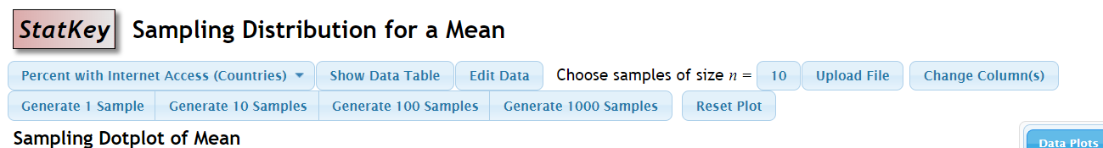

- Describe the shape, center, and variability of the population distribution for the number of people in a rock band (the graph on the upper right). Be sure to describe the center and variability in the context of the problem.

The shape of the population distribution is right-skewed, it’s center is at 2.864, and the standard deviation is 2.25.

- At your table, assign each of the sample size ranges listed below to a different person, have each person choose a sample size (n) in the range, and record the choices here:

Sample size range | Person | Chosen sample size (n)
6 - 15 | Patrick | 15
16 - 25 | Benny | 20
26 – 35  36 – 50 | Quywo  Melissa
51 -75 (if a 5th person) | Muzmal
76-100 (if a 6th person) | Ri | 85

- For each person, create a simulated sampling distribution based on your sample size.

- Click the button that shows 10, next to the Choose samples of size n =. Enter the sample size value you chose.

- Generate at least 10,000 samples.

- In the upper left-hand corner of the graph, there are three boxes. Click on the one in the middle, to the left of “Two-Tail”. Your graph should now have red bars on either end.

- Share a screenshot of the sampling dotplot below based on your sample size (in the key: only share if your sample size is more than a couple of rock bands different, and no more than 2 per range)
- Sample size between 6 and 15 rock bands: n =

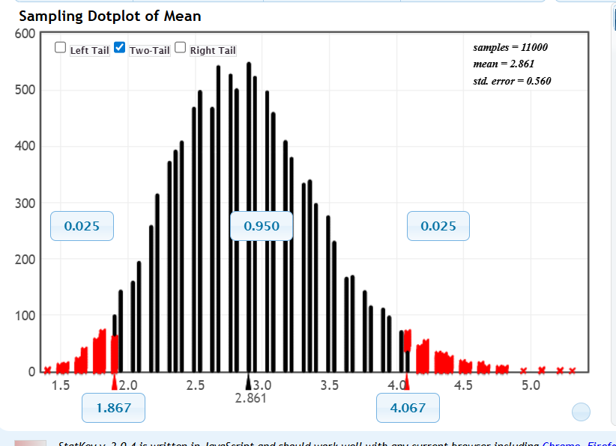

- Sample size between 16 and 25 rock bands: n =

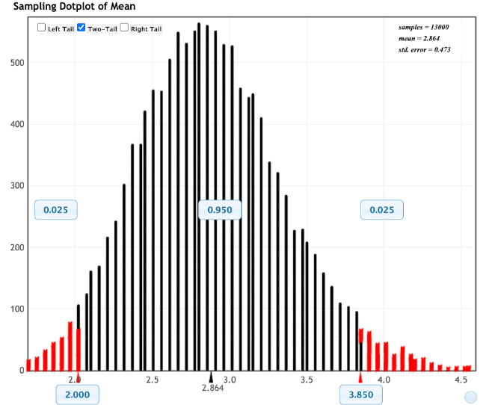

- Sample size between 26 and 35 rock bands: n =

- Sample size between 36 and 50 rock bands: n =

- (if there’s a 5th person at your table) Sample size between 51 and 75 rock bands: n =

- (and a 6th person at your table) Sample size between 76 and 100 rock bands: n =

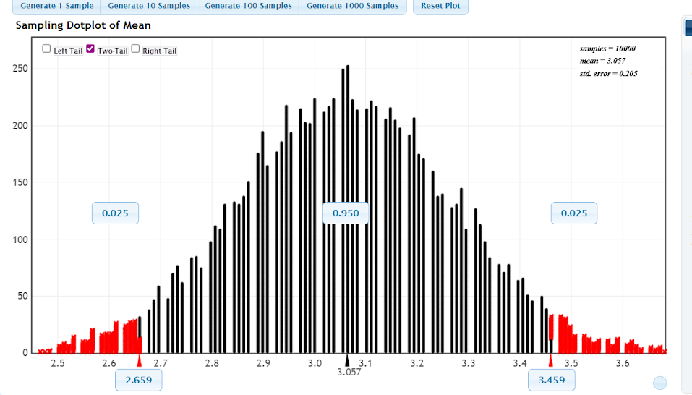

In order for the sampling distribution to be normal, it must first be symmetric. You should see two numbers appear in blue boxes below red arrows that are at the edges of the red bars. These represent the outer boundaries of the middle 95% of sample means. We will use these to look at symmetry

- For each sampling distribution, write down the sample size, and then the following three values from below the sampling distribution:
Sample size (n) | Number under left red arrow (bottom edge of 95%) | Number under black arrow (mean) | Number under right red arrow (top edge of 95%)
15 | 1.867 | 2.861 | 4.067
20 | 2.000 | 2.864 | 3.850
85 | 2.659 | 3.057 | 3.459

- If the sampling distribution is symmetric, the distance from each red arrow to the mean should be the same. Calculate that distance for each distribution:

Sample size (n) | Mean – bottom edge | Top edge - mean | Approx. equal?
15 | 0.994 | 2.2 | No

- At what sample size did the two ranges end up approximately equal? Does the shape of the graph of sample means look normal?

- Many people use n=30 as “large enough” for the Central Limit Theorem to hold, regardless of the population distribution. Do you think this is reasonable? Why or why not?

Yes and no. I think it entirely depends on the size of the population itself. For instance, if the population size itself is 40 people, a sample size of n=20 may be sufficient enough.

You have explored sampling distributions for a mean and what factors affect the characteristics of the distribution. However, in real life, you usually collect a single sample for a research study and not 10,000 samples. You will next investigate how to estimate the population mean from a single sample via confidence intervals.

CONFIDENCE INTERVALS FOR A MEAN

Background:
The common concept of 98.6°F (37°C) being the normal human body temperature was established in the 19th century. Recent studies, however, have critically examined the normal body temperature of 98.6°F,. One study obtained body temperatures from 50 healthy adults. The researchers were interested in the following research question: What is the average body temperature for healthy humans?

The body temperature data of the 50 adults can be found on Canvas, titled BodyTempSample.csv.

- Load into the data into R or SAS.

- Using your software of choice, calculate summary statistics for the BodyTemp variable. Fill in the values in the table below. Share your code and output.

 | Mean | Median | Q1 | Q3 | IQR | Range | Min | Max | SD
Body Temperature | 98.26 | 98.2 | 97.80 | 98.80 | 1 | 4.4 | 96.40 | 100.80 | 0.7653

- Using your software of choice, create a graphical display for the BodyTemp variable. Share your code and output.

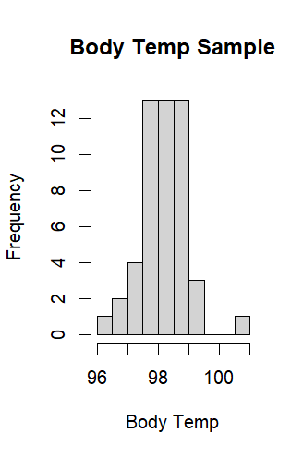
hist(x=bodyt$BodyTemp,
main = "Body Temp Sample",
xlab = "Body Temp",
ylab = "Frequency")
- Using both the summary statistics and the graph, do you think the sample is large enough for the Central Limit Theorem to hold? In other words, is the sample size (n) large enough, based on the summary data, to assume that the sampling distribution for a mean is approximately normal? Explain your reasoning.

I do think the CLT holds because the sampling distribution appears symmetrical.

- Using the summary statistics information, calculate the estimated standard error for the mean (SEM).

??
- Using your software of choice, find the t-value for a 95% confidence interval for the appropriate degrees of freedom. Share your code and output.

- Using your software of choice, calculate an 95% confidence interval for the population mean body temperature for healthy adults. Share your code and output.

- The average body temperature is accepted to be 98.6 degrees Fahrenheit. Is this value in your confidence interval? What does this imply if it is or is not in the confidence interval?

- Using the confidence interval calculated, answer the research question posed at the beginning of this section.

Now let’s practice finding confidence intervals for different confidence levels in your software of choice.

- Using your software of choice, calculate an 90% confidence interval for the population mean body temperature for healthy adults. Share your code and output.

- Using your software of choice, calculate an 99% confidence interval for the population mean body temperature for healthy adults. Share your code and output.

- Based on your answers to questions 31, 34, and 35, how would you summarize the effect of increasing the confidence level?

- Is the value of 98.6 degrees Fahrenheit in any of your confidence intervals? What does this imply if it is or is not in the confidence interval?

Mackowiak, P.A., Wasserman, S.S., & Levine, M.M. (1992). A critical appraisal of 98.6°F, the upper limit of the normal body temperature, and other legacies of Carl Reinhold August Wunderlich. The Journal of the American Medical Association, 268(12), p. 1578-1580.
Sund-Levander, M., Forsberg, C., & Wahren, L.K. (2002). Normal oral, rectal, tympanic and axiliary body temperature in adult men and women: a systematic literature review. Scandinavian Journal of Caring Sciences, 16, p. 122-128.

